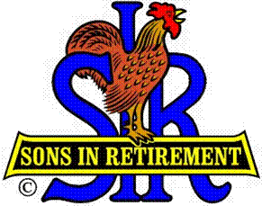

Las Trampas Branch 116

Luncheon Meeting Agenda

July 18, 2018

11:30 AM
- Call to Order – Big Sir.
- Welcome
- Pledge of Allegiance.
- Invocation: Michael Barrington
- Introduce Head Table
- Little Sir: Jerry Hicks please introduce our Guest Speaker
- Guest Speaker – Jim Caponigo, President and CEO of The Greater East Bay Goodwill Industries
- Story Teller Pete Coggiola
- Introduce Guests & Visitors
- Guests:
- Visitors:
- Guests
- Introduce New Members
- Big Sir Comment
- NEW SEATING FORMAT
- August is Hawaiian Shirt Day
- Special Picnic Buffett Lunch in August

11:45 PM – Lunch
- Sunshine Report

12:15 PM
- Committee Reports
- Golf Presentations, September RENO GOLF OUTING

12:30 PM
Little Sir:
- Introduce Guest Speaker – Jim Caponigo
- Raffle
- Ask July Birthday guys to stand / sing Happy Birthday (Paul King & Robbie)
- Sign God Bless America.

ADORJN

